
SIR SYED UNIVERSITY OF ENGINEERING & TECHNOLOGY
COMPUTER ENGINEERING DEPARTMENT
Software Requirement Specification
LogAI | AI-Powered Log Monitoring Dashboard
B.S. in Computer Engineering, Batch 2022F
Internal Advisor: ______________________________
Project Team
Name | Roll No | Section | Role | Contact
Khalid Hussain | 2022F-BCE-130 | B | Group Leader | 03322425697
Nauman Khalid | 2022F-BCE-147 | A | Member | 03295658357
Ahmed Sartaj | 2022F-BCE-212 | A | Member | 03303092753
Nauroz Saleem | 2022F-BCE-150 | A | Member | 03032809169

Karachi, Pakistan
May 29, 2026

Contents
1.1 Introduction
1.1.1 Product Purpose
1.1.2 Product Scope
1.1.3 System Diagram and Description
1.1.4 Project Stakeholders
1.1.5 Project WBS and Gantt Chart
1.1.6 Assumptions and Constraints
1.2 Project Functional Requirements
1.2.1.1 Chat Assistant Details
1.3 Project Non-Functional Requirements
1.3.7 Verification and Testing Strategy
1.3.8 Risks and Mitigation
1.4 Software Design Methodology
1.5 External Interface Requirements
1.6 Entity Relationship Diagram
1.7 Sequence Diagram
1.8 Future Improvements

List of Figures
Figure 1.1: LogAI System Diagram
Figure 1.2: UI/UX Prototype Overview
Figure 1.3: Use Case Diagram
Figure 1.4: Entity Relationship Diagram
Figure 1.5: Sequence Diagram

1.1 Introduction
LogAI is a web-based observability platform designed to centralize log ingestion, real-time monitoring, anomaly detection, alerting, and analytics for modern software systems.
The system combines a React frontend, a FastAPI backend, a dedicated Node.js auth service, Redis-based streaming, Elasticsearch-based search and analytics, PostgreSQL-based user metadata, and containerized deployment assets.
This SRS documents the current product requirements, interfaces, architecture, and design expectations for the final year project build. Performance values in this report are acceptance targets and should be validated against the live stack during the final verification run.

1.1.1 Product Purpose
The purpose of LogAI is to help operations teams, developers, and system administrators collect, observe, and analyze application logs from multiple sources in one place.
The system is intended to shorten debugging time, improve operational awareness, surface anomalies quickly, and provide a cleaner workflow for log search, live monitoring, and outbound alerting.

1.1.2 Product Scope
LogAI supports secure user authentication, monitored server registration, API-key-based log ingest, Fluentd-based collection, log parsing, anomaly scoring, real-time streaming to the dashboard, search and filtering, analytics, alert integrations, and a lightweight chat assistant that explains log context.
The current build also includes starter CI/CD, Docker Compose deployment assets, a reusable testing layer, and an Isolation Forest based anomaly engine with a statistical fallback path.

1.1.3 System Diagram and Description
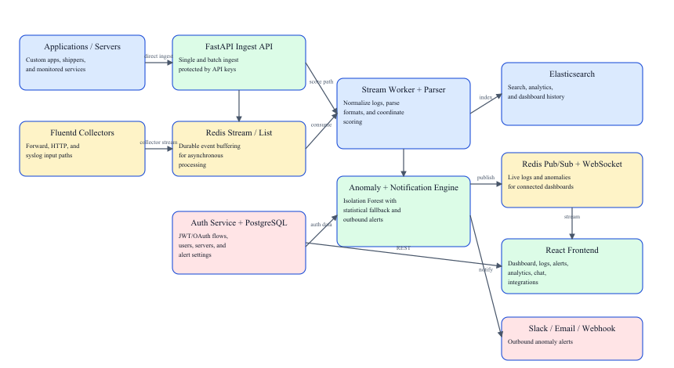
Figure 1.1: LogAI System Diagram
Applications and servers submit logs either directly to the FastAPI ingest API or through Fluentd collectors.
Redis Streams and Redis Lists decouple ingestion from processing so the stream worker can parse, score, and route logs reliably.
The anomaly engine evaluates each log entry, then indexed logs are stored in Elasticsearch while live updates are published to Redis Pub/Sub.
The React dashboard consumes historical data through REST APIs and live updates through the WebSocket endpoint.
When anomalies exceed a configured threshold, outbound notifications can be dispatched through Slack, email, and generic webhooks.

1.1.4 Project Stakeholders
Stakeholder | Role / Interest
DevOps Engineers / SREs | Primary users who monitor infrastructure health, incidents, and log anomalies.
Software Developers | Investigate errors, search logs, and use analytics and chat assistance during debugging.
System Administrators | Maintain the deployment, configure infrastructure, rotate keys, and manage environments.
Project Team | Responsible for requirements, implementation, documentation, and future improvement of the system.
Project Advisor / Academic Evaluators | Review system scope, architecture, correctness, testing, and deliverables.
Cloud / Hosting Providers | Provide the runtime resources used by the databases, backend services, and frontend deployment.
Alert Delivery Services | Slack workspaces, SMTP providers, and webhook receivers that deliver anomaly notifications.

1.1.5 Project WBS and Gantt Chart
WBS | Work Package | Description
1.0 | Requirement analysis and proposal alignment | Clarify scope, required features, and evaluation milestones.
2.0 | Backend platform | Authentication, server management, ingest routes, search, analytics, and chat APIs.
3.0 | Frontend dashboard | Connected user interface for dashboard, logs, alerts, analytics, servers, chat, and integrations.
4.0 | Real-time pipeline | Redis streams, stream worker, WebSocket live updates, and anomaly event propagation.
5.0 | Deployment structure | Docker Compose stack, CI/CD starter, and workspace cleanup.
6.0 | Alerting and AI/ML | Slack/email/webhook integrations and Isolation Forest anomaly scoring.
7.0 | Testing and documentation | Smoke tests, load tests, architecture notes, run guides, and report artifacts.

Task | P1 | P2 | P3 | P4 | P5 | P6 | P7
Requirement analysis | Active
Backend core implementation | Active | Active
Frontend integration and UX |  | Active | Active | Active
Real-time pipeline |  | Active | Active
Deployment and repo structure |  |  | Active | Active
Alerting and integrations |  |  |  |  | Active
AI/ML upgrade |  |  |  |  |  | Active
Hardening, testing, documentation |  |  |  |  |  |  | Active

1.1.6 Assumptions and Constraints
The deployment environment provides Docker Desktop or an equivalent container runtime for the local stack.
Node.js 18+ and Python 3.11+ are available when frontend development and local testing scripts must be run outside containers.
SMTP, Slack, webhook, and OAuth behavior depends on valid third-party credentials being supplied through environment variables.
The current deployment path is Docker Compose for local and demo execution.
The current chat assistant is retrieval and rule based; it should not be described as a general-purpose foundation model.
Final performance numbers and screenshots depend on a live system test pass and are not fully measurable from static code inspection alone.

1.2 Project Functional Requirements

1.2.1 Project Functional Features
ID | Requirement | Description | Priority
FR-01 | User registration and login | The system shall support local email/password signup, login, logout, token refresh, and profile retrieval. | High
FR-02 | OAuth callback support | The system shall support Google and GitHub OAuth redirection through the auth service. | Medium
FR-03 | Server management | The system shall allow an authenticated user to create, list, soft-delete, and rotate API keys for monitored servers. | High
FR-04 | Single log ingest | The system shall accept a single log entry through an API-key-protected ingest endpoint. | High
FR-05 | Batch log ingest | The system shall accept up to 1000 log entries in one batch request. | High
FR-06 | Collector-based ingest | The system shall support Fluentd and Redis-based pipeline ingest in addition to direct API ingest. | High
FR-07 | Log parsing and normalization | The system shall parse common raw log formats and normalize them into a shared searchable structure. | High
FR-08 | Real-time streaming | The system shall push new logs and anomalies to connected dashboard clients through WebSocket updates. | High
FR-09 | Search and filtering | The system shall let users query logs by server, severity, anomaly flag, text search, and time range. | High
FR-10 | Dashboard metrics | The system shall present 24-hour overview metrics, severity breakdowns, hourly activity, and per-server health summaries. | High
FR-11 | Analytics views | The system shall provide detailed server metrics, anomaly counts, severity charts, and trend data. | High
FR-12 | Alert management | The system shall display anomaly events and support live alert updates in the frontend. | High
FR-13 | Outbound integrations | The system shall allow users to configure Slack, email, and webhook channels and send test notifications. | High
FR-14 | AI-assisted chat | The system shall let users ask questions about their logs and receive Elasticsearch-backed contextual responses derived from recent indexed data. | Medium
FR-15 | Deployment assets | The system shall include Docker-based local deployment assets for repeatable setup and demo execution. | Medium
FR-16 | Testing support | The system shall include smoke-test and ingest load-test utilities for final verification. | Medium

1.2.1.1 Chat Assistant Details
The current chat feature is not a hosted large language model integration in the deployed build.
It works by querying Elasticsearch for recent logs relevant to the user's message, then composing a contextual response through rule-based response logic in the backend.
Its data source is therefore the user's own indexed log history, filtered by owned servers and recent time windows.
This makes the current build deterministic, lightweight, and fully local to the project stack, while still giving useful debugging assistance.

1.2.2 Operating Environment
Environment Item | Current Build Expectation
Client browser | Chrome, Edge, or Firefox on Windows, Linux, or macOS
Frontend runtime | Node.js 18+ during development, static frontend served by NGINX in deployment
Backend runtime | Python 3.11+ for FastAPI backend and stream worker
Auth runtime | Node.js service for OAuth and callback handling
Primary databases | PostgreSQL 16, Elasticsearch 8.x, Redis 7
Collection layer | Fluentd with forward, HTTP, and syslog inputs
Container environment | Docker Desktop / Docker Compose for local stack execution
Network prerequisites | HTTP/HTTPS access plus database, Redis, and collector ports where applicable

1.2.3 UX Prototype
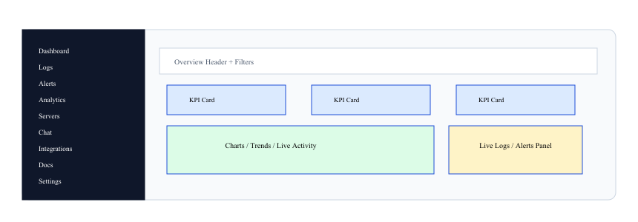
Figure 1.2: UI/UX Prototype Overview
Authentication: Login and signup flow with local auth and OAuth callback support.
Dashboard: Overview cards, live logs, anomaly preview, and per-server summary.
Logs: Search, filters, pagination, and anomaly-only exploration.
Alerts: Live anomaly view with server scoping and feed behavior.
Analytics: Trend charts, severity breakdowns, and anomaly metrics.
Servers: Create/list servers, view API keys, and manage monitored systems.
Integrations: Configure Slack/email/webhook delivery and send test alerts.
Chat: Ask log-related questions and receive contextual responses.

1.3 Project Non-Functional Requirements

1.3.1 Performance Evaluation
The following values are acceptance targets pending the final live verification run.
Metric | Acceptance Target
Health endpoint response | < 1 second under normal local deployment load
Single ingest request | < 500 ms average under light load
Batch ingest limit | Up to 1000 log entries per request
Dashboard overview query | < 3 seconds for the 24-hour aggregate view
Log search query | < 2 seconds for common filtered queries with paginated output
WebSocket live update delivery | Visible in the frontend within 2 seconds after processing
Notification dispatch | < 10 seconds for configured Slack/email/webhook channels
Load-test baseline | Support a local benchmark run of at least 200-300 ingest requests using the included test script

1.3.2 Safety Requirements
The system shall never perform destructive remediation actions automatically on monitored infrastructure.
The system shall preserve log evidence and anomaly metadata even when live streaming is temporarily unavailable.
The system shall fail gracefully by returning informative errors instead of silently dropping authenticated user actions.
The system shall continue using the statistical anomaly fallback when the ML model is not trained or unavailable.

1.3.3 Security Requirements
JWT access and refresh tokens shall be used for authenticated user APIs.
Passwords shall be stored as bcrypt hashes and never persisted in plain text.
API-key-based ingest shall be isolated per monitored server.
User access to servers, metrics, logs, and integrations shall be scoped to owned resources only.
Rate limiting shall be applied to sensitive API flows such as ingest traffic.
Secrets such as JWT keys, OAuth credentials, SMTP credentials, and webhook URLs shall be supplied through environment variables or secret stores.
Production deployment should enable HTTPS/TLS at the reverse-proxy layer.

1.3.4 Business Perspective / Requirements
LogAI addresses a practical observability need for student projects, internal systems, and small to medium operational teams that need centralized log visibility without a large commercial stack.
The product reduces manual debugging effort by combining live streams, stored history, analytics, anomaly scoring, and outbound alerting in one workflow.
The platform is intentionally modular so future work can add richer ML, hosted deployment hardening, or organization-level roles without redesigning the whole system.

1.3.5 Licensing Requirements
The current build depends on open-source frameworks and libraries such as React, FastAPI, SQLAlchemy, Redis clients, Elasticsearch clients, and report/test tooling.
Any public distribution of the project should include a top-level project license and third-party attribution review before release.
External services such as Slack, SMTP providers, and cloud infrastructure remain subject to their own service terms and licenses.

1.3.6 Legal Copyrights and Notices
Organizations deploying LogAI remain responsible for the legality of collected log data, retention policies, and privacy obligations.
The system may process sensitive operational or personal data if applications emit it into logs; therefore, deployers should implement masking, retention limits, and access controls appropriate to their context.
Evidence, alerts, and exported diagnostics should be handled according to local security policies and any applicable data-protection regulations.

1.3.7 Verification and Testing Strategy
ID | Validation Area | Expected Check | Method
TS-01 | Health verification | Validate backend health and auth health endpoints before feature testing. | Automated smoke test
TS-02 | Authentication flow | Verify signup, login, token refresh, logout, and OAuth callback behavior. | Manual bug bash
TS-03 | Server lifecycle | Create servers, list them, and rotate keys without cross-user access leakage. | Manual + API check
TS-04 | Ingest validation | Send single and batch logs with valid API keys and confirm persistence. | Manual + smoke test
TS-05 | WebSocket validation | Confirm live logs and anomaly events reach the dashboard in real time. | Manual live test
TS-06 | Analytics and alerts | Validate alert feed, metrics pages, and anomaly counters against ingested data. | Manual live test
TS-07 | Integration delivery | Save Slack/email/webhook configuration and send a synthetic test notification. | Manual live test
TS-08 | Anomaly-model validation | Warm the model with at least 100 logs and compare fallback vs ML-active behavior. | Manual live test
TS-09 | Load testing | Run the ingest load test script and record throughput plus latency metrics. | Automated load test

1.3.8 Risks and Mitigation
Risk ID | Risk | Impact | Mitigation
R-01 | Backend or database service failure | Dashboard pages may fail to load or ingest may stop. | Use health checks, container restarts, and service-level logs to detect and recover quickly.
R-02 | High ingest load | Queue build-up, slower indexing, or delayed live updates. | Use Redis buffering, batch indexing, load testing, and future horizontal scaling.
R-03 | Notification channel misconfiguration | Important anomaly alerts may not be delivered. | Provide test-send flows, readiness indicators, and per-channel configuration validation.
R-04 | Model false positives or false negatives | Users may miss incidents or get noisy alerts. | Keep statistical fallback, tune thresholds, and document model warm-up behavior.
R-05 | Invalid or noisy log payloads | Parsed data quality and analytics accuracy may degrade. | Normalize formats, support raw preservation, and store metadata for later inspection.
R-06 | Secret leakage or weak configuration | Unauthorized access to APIs or third-party integrations. | Use environment variables, secret stores, API key rotation, and JWT-based access control.

1.4 Software Design Methodology
The system follows a modular, service-oriented design with clear separation between user-facing frontend flows, API orchestration, asynchronous stream processing, storage layers, and alert delivery.
Development is aligned with an iterative and incremental approach: core backend services, connected frontend flows, live streaming, deployment structure, alerting, AI/ML upgrade, and final hardening were introduced in phases.
The backend uses REST for historical and administrative operations, WebSocket for live updates, Redis for event movement and rate limiting, Elasticsearch for search and analytics, and PostgreSQL for user-owned metadata.

1.4.1 Data Dictionary / Data Set
Field | Type | Description
users.id | UUID | Primary key for each user.
users.name | String(255) | Display name of the user.
users.email | String(255) | Unique login and contact identity.
users.hashed_password | String(255) | Bcrypt-hashed password for local auth.
users.picture | String(1024) | Optional avatar URL.
users.auth_provider | Enum | Authentication source: local, google, or github.
users.oauth_id | String(255) | Optional OAuth provider identifier.
users.is_active | Boolean | Soft-active flag for the account.
servers.id | UUID | Primary key for each monitored server/application.
servers.name | String(255) | Display name of the monitored server.
servers.description | Text | Optional descriptive notes.
servers.api_key | String(255) | Unique API key used for log ingestion.
servers.owner_id | UUID | Foreign key to the owning user.
servers.is_active | Boolean | Soft-active flag for the server.
alert_integrations.owner_id | UUID | Unique foreign key linking one integration profile to one user.
alert_integrations.slack_enabled | Boolean | Enables Slack notifications.
alert_integrations.slack_webhook_url | String(1024) | Slack Incoming Webhook URL.
alert_integrations.email_enabled | Boolean | Enables email notifications.
alert_integrations.email_recipients | Text | Comma-separated email recipients.
alert_integrations.webhook_enabled | Boolean | Enables generic webhook delivery.
alert_integrations.webhook_url | String(1024) | Webhook endpoint URL.
alert_integrations.minimum_anomaly_score | Float | Threshold required before outbound alerting.

Field | Type | Description
logai-logs.id | keyword | Unique log document identifier.
logai-logs.server_id | keyword | Owning server identifier.
logai-logs.server_name | keyword | Human-readable server name.
logai-logs.level | keyword | Normalized severity level.
logai-logs.message | text + keyword | Primary searchable log message.
logai-logs.source | keyword | Logger or collector source.
logai-logs.host | keyword | Origin host name.
logai-logs.service | keyword | Application service or subsystem.
logai-logs.environment | keyword | Environment tag such as dev/staging/prod.
logai-logs.meta | object | Dynamic structured metadata payload.
logai-logs.raw | text | Original raw message when preserved.
logai-logs.anomaly | boolean | Boolean anomaly classification.
logai-logs.anomaly_score | float | 0..1 anomaly score.
logai-logs.timestamp | date | Primary event time in epoch millis.
logai-logs.ingested_at | date | Time the system accepted the record.
logai-logs.processed_by | keyword | Pipeline source such as api-direct, stream, or fluentd.

1.4.2 Design Models [along with descriptions]
Model | Purpose
System architecture model | Describes the high-level components and data paths from sources to dashboards and alert channels.
Use case model | Shows how authenticated users, monitored applications, and notification channels interact with the system.
Entity relationship model | Defines the persistent ownership relationships between users, servers, alert integrations, and log documents.
Sequence model | Explains the order of calls during a log-ingest-to-dashboard event.

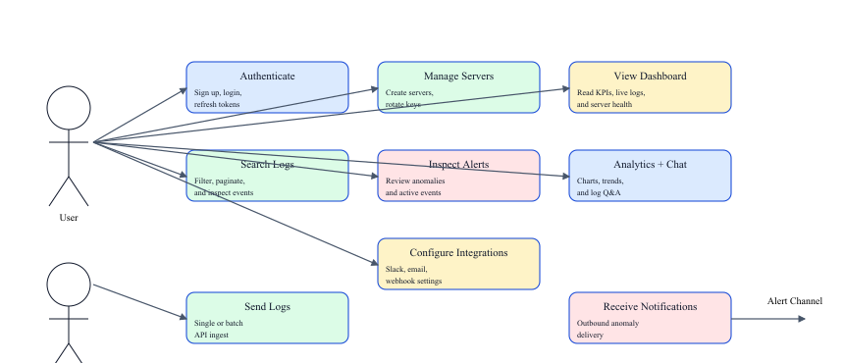
Figure 1.3: Use Case Diagram

1.5 External Interface Requirements
Interface | Protocol | Direction | Description
POST /api/v1/auth/signup | HTTPS | Client -> FastAPI | Register a local user account and receive access/refresh tokens.
POST /api/v1/auth/login | HTTPS | Client -> FastAPI | Authenticate a local user and receive tokens.
POST /api/v1/auth/refresh | HTTPS | Client -> FastAPI | Issue a new access token using a refresh token.
GET /api/v1/auth/me | HTTPS | Client -> FastAPI | Return the authenticated user profile.
GET /api/v1/servers | HTTPS | Client -> FastAPI | List owned servers with 24-hour statistics.
POST /api/v1/servers | HTTPS | Client -> FastAPI | Create a monitored server and API key.
GET /api/v1/servers/{id}/metrics | HTTPS | Client -> FastAPI | Fetch detailed server metrics.
GET /api/v1/servers/dashboard/overview | HTTPS | Client -> FastAPI | Fetch dashboard-wide overview data.
POST /api/v1/ingest | HTTPS + x-api-key | Application -> FastAPI | Submit one log entry.
POST /api/v1/ingest/batch | HTTPS + x-api-key | Application -> FastAPI | Submit a batch of logs.
GET /api/v1/logs | HTTPS | Client -> FastAPI | Search and filter indexed logs.
POST /api/v1/chat | HTTPS | Client -> FastAPI | Ask a contextual question about current logs.
GET /api/v1/integrations/alerts | HTTPS | Client -> FastAPI | Load alert integration settings.
PUT /api/v1/integrations/alerts | HTTPS | Client -> FastAPI | Update alert delivery settings.
POST /api/v1/integrations/alerts/test | HTTPS | Client -> FastAPI | Send a synthetic test alert.
WS /ws?token=...&server_id=... | WebSocket | Client <-> FastAPI | Receive live log and anomaly events and switch subscriptions.
GET /api/auth/google, /api/auth/github | HTTPS | Client -> Auth Service | Start OAuth authentication flows.
GET /api/auth/health | HTTPS | Client -> Auth Service | Health endpoint for auth service validation.

Communication Path | Technology
Frontend to backend | HTTPS REST + WebSocket
Backend to PostgreSQL | Async PostgreSQL driver
Backend / worker to Redis | Redis streams, lists, pub/sub, and sorted sets
Backend / worker to Elasticsearch | HTTP API via async client
Fluentd to Redis | Collector pipeline
Alert delivery | Slack webhook, SMTP, generic outbound webhook

Recommended manual bug-bash coverage
Authentication and token refresh
OAuth callback flow
Server creation and API key rotation
Single and batch ingest
Live dashboard WebSocket stream
Logs filtering and pagination
Alerts feed behavior
Analytics values and charts
Integrations save and test-send flow
Chat response quality for recent logs

1.6 Entity Relationship Diagram
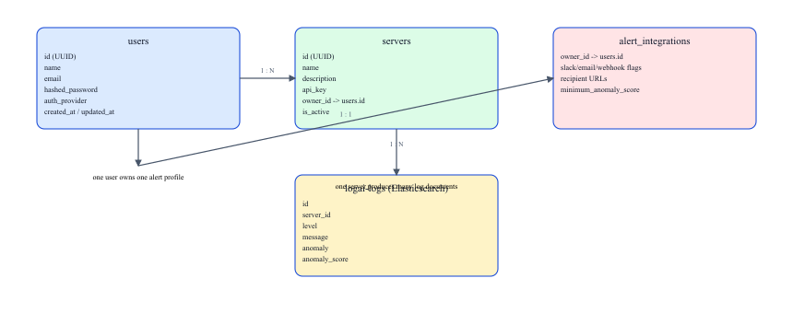
Figure 1.4: Entity Relationship Diagram

1.7 Sequence Diagram
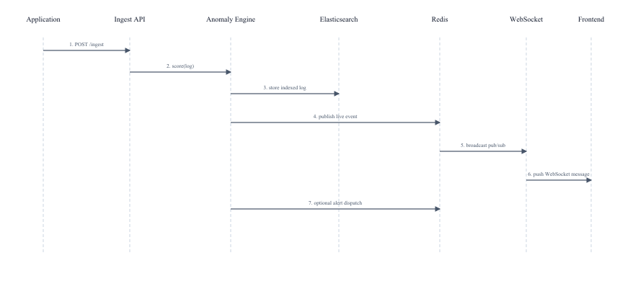
Figure 1.5: Sequence Diagram

1.8 Future Improvements
Upgrade the current rule-based chat assistant to a stronger retrieval-augmented AI workflow or hosted LLM integration.
Explore richer anomaly models such as sequence-aware models, ensemble scoring, and feedback-driven threshold tuning.
Add a hosted deployment path with production-grade monitoring, persistence, TLS, and scaling controls.
Add organization-level roles, audit trails, retention policies, and multi-tenant support.
Introduce formal automated E2E browser tests in addition to the current smoke and load scripts.

